Washington Location Based Services
Overview of Services, Rates and Commitments

The enterprise support of Location Based Services provides a common point of access to services that promote the easy access and use of location enriched data and services. The enterprise Portal is the mechanism that enables efficiencies to be gained by reducing the duplication of data and decreasing infrastructure and storage that would otherwise be needed by multiple state agencies. Our shared service objectives include:

• Strategic data investments
• Coordinated data acquisitions
• Efficient data storage
• Reduced duplication of state time
• Effective software licensing
• Improved coordination
• Shared geospatial web services
• Common data distribution platform

Business Value
A shared enterprise approach to handling location based data and services advances customer services by providing various agency users with access to commonly used information, data resources, standards and web based services from a single environment. This approach has been successfully implemented in other states like Minnesota, Maryland and Montana and they have seen both savings and efficiencies in this service model.

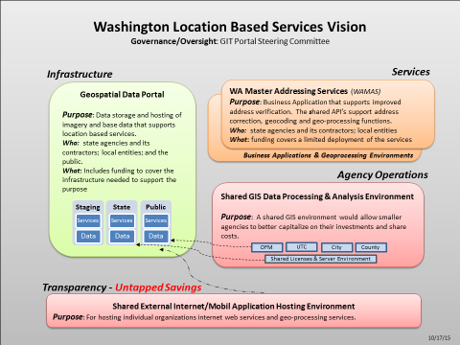

Fee Structure
The present fee structures were enacted by the State Legislature in 2013 and 2014. These fees cover basic infrastructure costs using either allocated or appropriated funds to state agencies.
The following state agencies were identified by the Geographic Information Technology (GIT) Committee as conducting some level of geospatial data activities within their organizations:
Agriculture; Ecology; Financial Management; Fish and Wildlife; Administrator of the Courts; Archelogy and Historic Preservation; Columbia Gorge Commission; Commerce; Enterprise Services; Health; Military Natural Resources; Recreation and Conservation Office; Revenue; Transportation; State Board for Community and Technical Colleges; Superintendent of Public Instruction; Utilities and Transportation; Office of the State Auditor; Corrections; Joint Legislative Services; Labor and Industries; Legislative Service Center; Lottery; Parks and Recreation Commission; Secretary of State; Social and Health Services; State Patrol.
Description of Services
The portal provides customers with the infrastructure needed to store, host and serve out shared resources important to conducting state business functions like permitting, licensing, taxation and protecting the public’s health and environment in Washington. This includes access to quality state and local resources like:
- Addressing Services: A set of 3 API’s that correct and standardize an address, finds its best location on the ground (x,y) and gives you it associated geography (county, legislative district, etc.)
- Data: A place to assemble, host and serve commonly used information like statewide Parcels, County and city boundaries, Address locations, Trails, urban growth areas and much more.
- Imagery: Coordinated access to valuable high resolution county and statewide imagery data that number close to 100 individual services.
- Other Services & API’s: Many of the services mentioned above are available in multiple formats making it easy for end users to ingest them into their mainframe, server or desktop applications and web bases service applications.
Think of it like state specific Google mapping resources!

Service Support
Based on funding levels, the Geospatial Portal Steering Committee currently defines service availability as:
- Ad-hoc technical user and application support available Monday through Friday from 7:00 AM to 6:00 PM
- Infrastructure up time is guaranteed Monday through Friday from 7:00 AM to 6:00 PM with acceptable outage or downtimes not to exceed 48 hours but our service provider strives for an uptime of 99 percent.

Governance
The technical oversight of these shared resources is coordinated through Geographic Information Technology (GIT) subcommittee which is composed of representatives from the user agencies. The committee works with WaTech IT Operations & Support Division on identifying and prioritizing infrastructure enhancements, and deployment of data and services.
The GIT Committee, which is administered by the Office of the Chief Information Officer (OCIO), provides executive leadership in:
- Developing a strategic, coordinated, enterprise approach to using geographic information technology.
- Implementing cost-effective, collaboratively-developed, spatial data management solutions.

More Information?
To leverage these Location Based Services or to become involved in the governance committee, please contact Joy Paulus (joy.paulus@ocio.wa.gov) at the OCIO.
For more information go to www.geography.wa.gov or https://ocio.wa.gov/programs/geospatial-program-office/washington-master-addressing-services-wamas

