Statewide Information Technology Strategic Plan 2021-2025
VISION Better Government Through Technology
MISSION Personalize and Optimized Government
PRINCIPLES Leadership | Enterprise Focused | Agility | Transparency | Data Driven

GOALS

GOAL #1 GOAL #2 GOAL #3 GOAL #4 GOAL #5

Efficient & Effective Government
Accountable IT Management
IT
Workforce
Enterprise Architecture
Security & Privacy

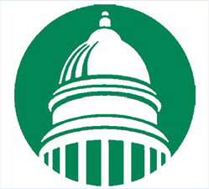
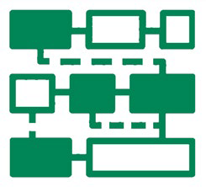
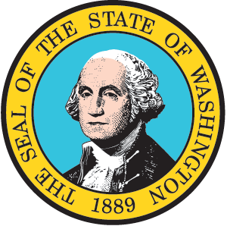
OBJECTIVES
- Advance digital government.
- Reduce barriers to access.
- Improve customer experience across channels.
- Expand integration between systems.

ENTERPRISE INITIATIVES
In progress or Planned
- Complete migration to cloud-based shared email service.
- Fully implement Enterprise M365 licensing approach.
- Implement One Washington.
- Increase access to broadband across state.
- Continue development of Master Person Index and Integrated Eligibility (HHS Coalition).
Proposed
- Develop digital citizen strategy to support “one government” view.
- Create shared accessibility community of practice and repository.
- Develop a statewide data management and integration solution.

OBJECTIVES
- Promote reuse with in-creased visibility into IT assets.
- Reduce technical debt.
- Align portfolio to statewide architecture.
- Improve project out-comes with better practices.
- Support value-based analysis of IT spend.

ENTERPRISE INITIATIVES
In progress or Planned
- Provide updated view of legacy applications and modernization needs.
- As part of One Washington, implement improvements to detailed technology spend data and analysis.
Proposed
- Design and implement enterprise configuration management strategy.
- Develop methods to identify business impact of IT spend to support savings or investment.

OBJECTIVES
- Support a diverse, resilient workforce.
- Implement an enterprise workforce development strategy.
- Improve support for re-mote work.
- Maintain a competitive classification and compensation structure.

ENTERPRISE INITIATIVES
In progress or Planned
- Develop a workforce training plan for cloud adoption.
- Create an organizational change management strategy and training plan to address new technology adoption.
- Increase availability of communities of practice.
Proposed
- Monitor and adjust ITPS to better support career paths and evolution of technology.
- Identify and implement inclusive recruitment and retention practices.
- Identify holistic organizational change management.

OBJECTIVES
- Advance adoption of modern, cloud-based technologies.
- Support use of common, shared technologies across agencies.
- Align with WA Government service domains.

ENTERPRISE INITIATIVES
In progress or Planned
- Establish Enterprise Cloud Computing Program.
- Update enterprise identity management strategy.
- Develop state’s enterprise architecture framework.
- Create shared hazards data sharing platform.
- Implement IPv6 across the enterprise.
Proposed
- Develop an enterprise integration strategy.
- Develop an enterprise data management and governance strategy.
- Assess state network in support of cloud strategy.
- Identify components and tools that can be standardized or shared across agencies.

OBJECTIVES
- Invest in proactive cyber solutions and practices.
- Recruit and develop cyber and privacy talent in state government.
- Deploy statewide privacy framework.
- Strengthen privacy capacity in state and local government.

ENTERPRISE INITIATIVES
In progress or Planned
- Create a catalog of standard security ser- vices.
- Update cybersecurity incident response processes and associated policy.
- Implement a privacy framework for agencies.
- Collaborate with local government to improve practices.
- Improve security operations and governance.

Proposed
- Improve disaster recovery practices.
- Develop cyber workforce initiative and associated measures.

